



MANUAL



[**Request Sample Probes and OSC1Lite**](https://form.jotform.com/82275611836157)

About 3

System Specifications and Features 3

System Setup 4

Included Items 4

System Requirements 4

Hardware Setup 5

Software Installation 6

GUI Usage 7

Waveform Setup 8

Calibration 9

Channel Control 9

Channel to LED mapping 9

Waveform selection 9

Trigger source 10

Channel mode 10

Trigger out 10

Channel status 11

Troubleshooting 12

Dead channels and alarms 12

Dead μLEDs 12

Noisy μLEDs (stimulation artifact) 12

Calibration 12

# About

OSC1Lite (OSC = Optical Stimulation Controller) was designed to drive μLED optoelectrodes[1] (see **Figure 1**), featuring 12 10x15μm LEDs (hence, μLED). μLED optoelectrodes are useful for optogenetic experiments requiring high spatial and temporal resolution (with simultaneous recording). The software for the system has been open-sourced[2], and the hardware is intended to be open-sourced soon.

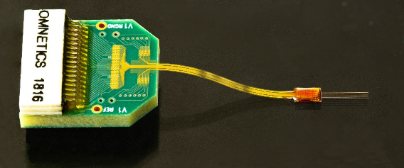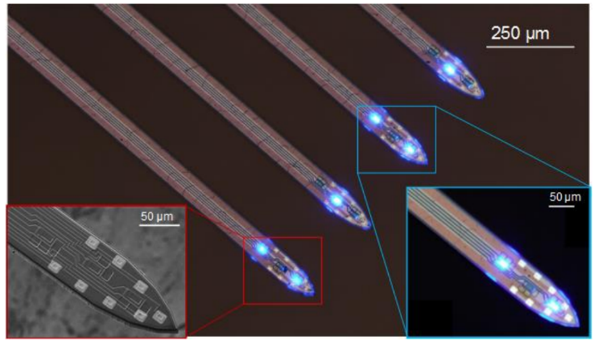

**Figure 1.** μLED optoelectrodes

# System Specifications and Features

**Table 1.** OSC1Lite System Specifications and Features

|  |  |  |
| --- | --- | --- |
|  | Min | Max |
| Current time step resolution | 8 μs |  |
| Current resolution | 400 nA |  |
| Current accuracy | 1 μA[3] | 400 nA |
| Current range | 0 | 100 μA |
| Zero-scale current[4] |  | 0 |
| Battery Life | 12 hours | 16+ hours |
| Trigger In | | Yes |
| Trigger out | | Yes |
| Individual waveform visualization4 | | Yes |
| Trapezoidal/square waveform[5] | | Yes |

# System Setup

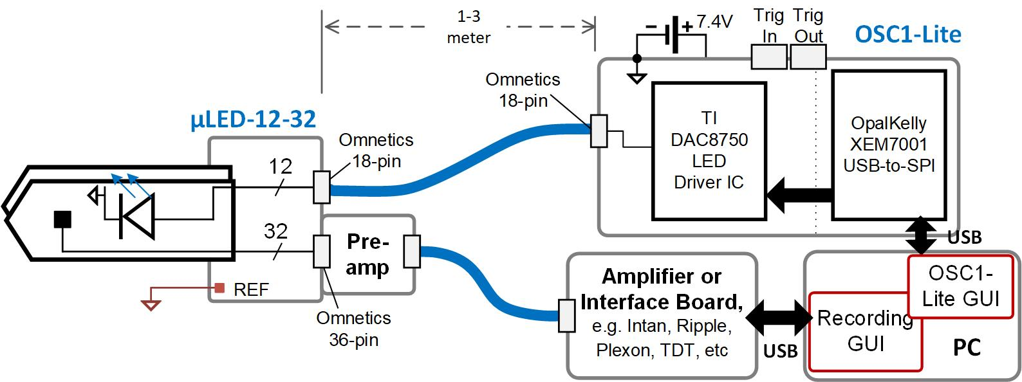

**Figure 2.** Typical system configuration with OSC1Lite

## Included Items

1 OSC1Lite board

1 USB cable

2 18650 li-Ion batteries

1 18650 battery charger

1 Cable with 18-pin Omnetics connectors (1 meter long)

## System Requirements

Windows 10 OS

Screen resolution above 1280x720

## Hardware Setup

Before setup, please be aware that when the batteries have low charge, the green ON LEDs will turn off, indicating that you must recharge the batteries. OSC1Lite hardware will be open sourced (PCB files and BOM) soon.

**Step 1** Charge both batteries using the provided charger, then insert them into the battery holder on the bottom of the PCB (**Figure 3**, right). Notice the orientation of the +/- indents on the battery holder, as well as the positive terminals (indented) on each battery in **Figure 3**. Please do not drop OSC1Lite, as the batteries may fall out. Please read the user manual for the battery charger and adhere to all the cautions and warnings (**lithium ion batteries are extremely dangerous if not properly handled**).

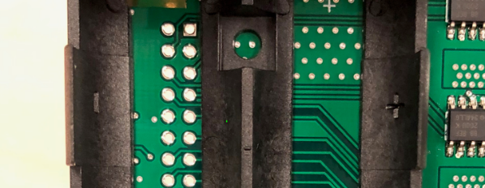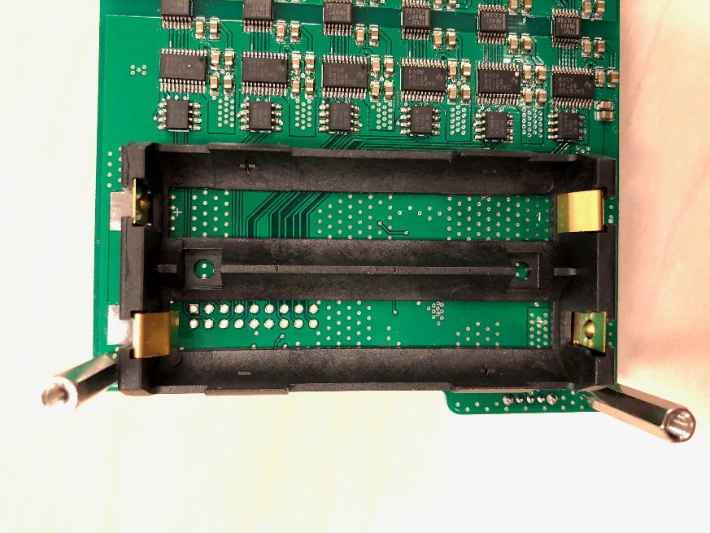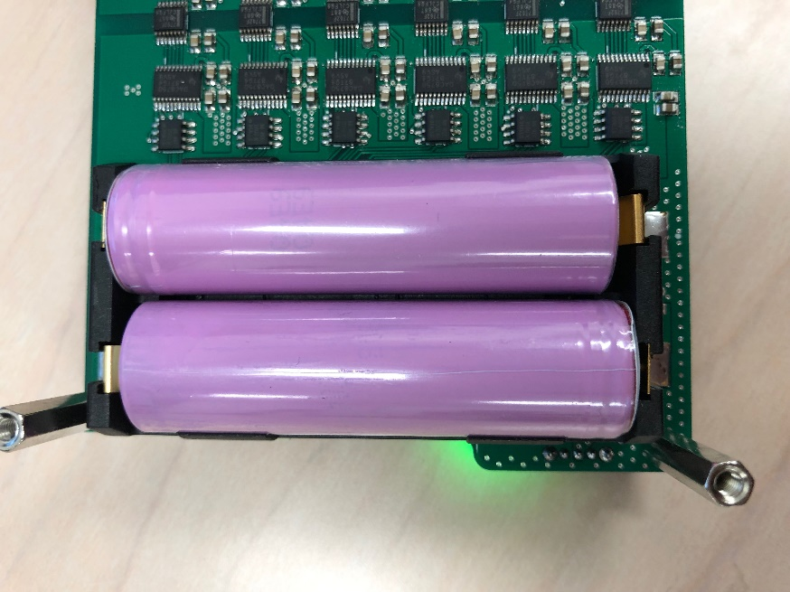

**Figure 3.** Bottom of OSC1Lite board (right: two 18650 batteries installed)

**Step 2** Flip the switch on the bottom right of the board (**Figure 4**). Two green LEDs should turn on. If you do not see any LEDs turn on:

1. Please ensure the batteries are charged, installed firmly, and in the correct orientation
2. Try pushing the batteries in the direction of the yellow arrows in **Figure 3**.
3. Try bending the battery holder’s metal clips on the negative terminals in the direction of the yellow arrows

**Step 3** Connect your computer to the Opal Kelly board using the USB cable provided (**Figure 4**). Take note of the last 3 alphanumeric characters of the Opal Kelly module as seen next to the barcode (**Figure 4**).

**Step 4** Connect the probe to the board using the 18-pin Omnetics cable provided[6] (note, whenever plugging or unplugging the probes, you may see the LEDs flicker. This is completely normal and safe for the LEDs).

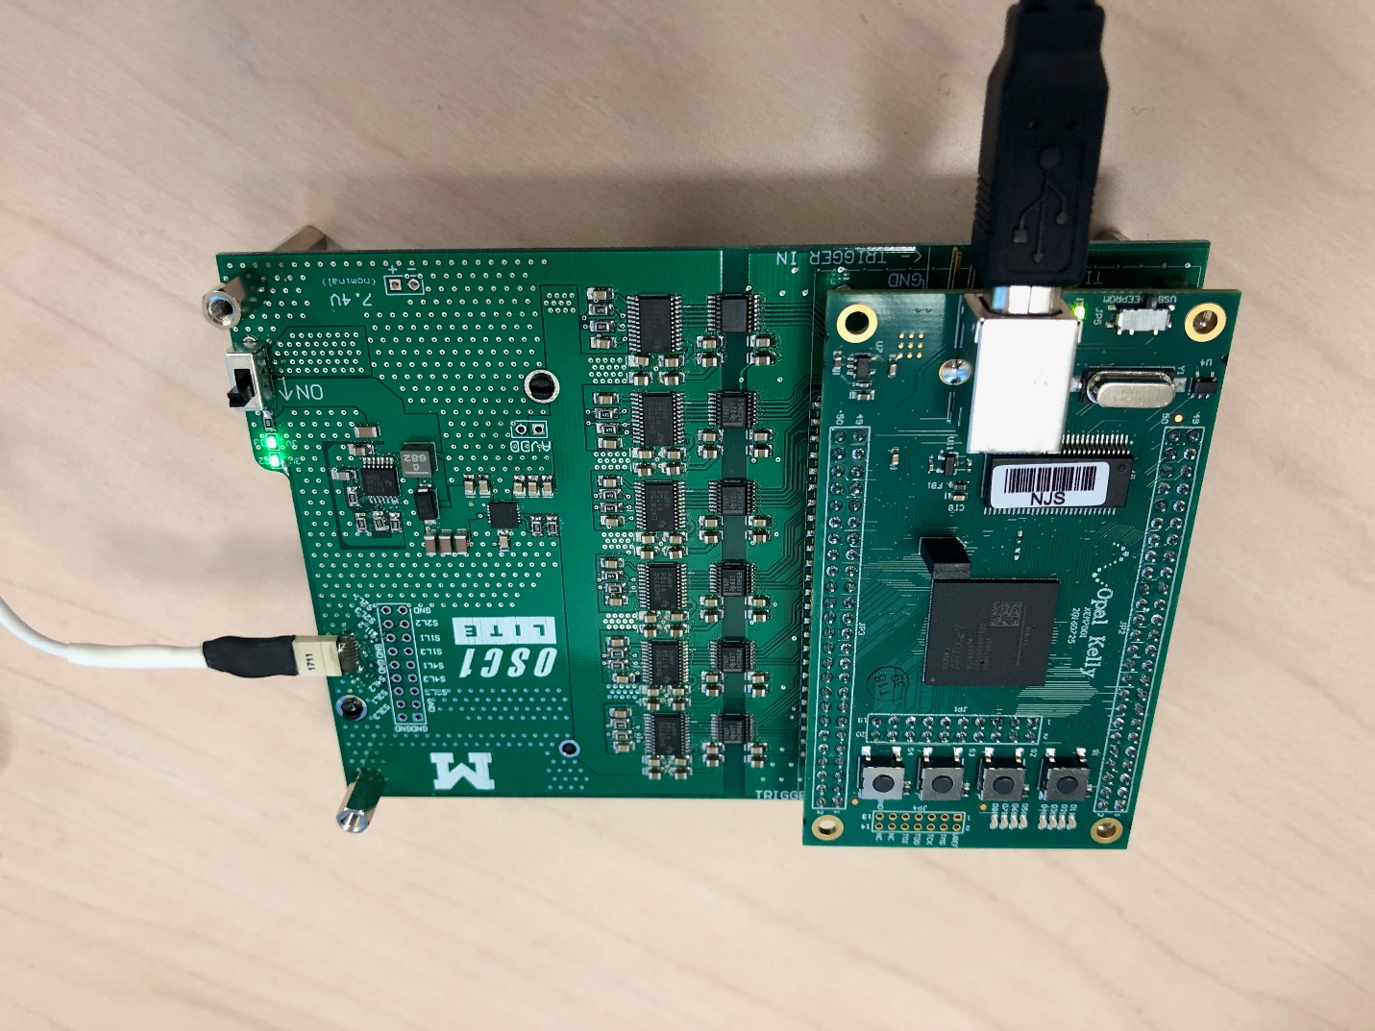

Opal Kelly Serial Number

Opal Kelly USB connectionn

On/off switch

**Figure 4.** Top of OSC1Lite board

## Software Installation

The GUI source code can be found at the [osc1lite GitHub page](https://github.com/YoonGroupUmich/osc1lite/releases)[7].

**Step 1** Install the Opal Kelly USB driver **version 4.5.6 or later**, [FrontPanelUSB-Win-x64-4.5.6.exe](https://github.com/YoonGroupUmich/osc1lite/releases/download/v2.0.0/FrontPanelUSB-Win-x64-4.5.6.exe). Note: you may have to reboot your computer for this to take effect. **FrontPanelUSB 4.5.5 will not work[8].**

**Step 2** Download and unzip [oscgui-win64.zip](https://github.com/YoonGroupUmich/osc1lite/releases/download/v2.0.0/oscgui-win64.zip). Open the GUI by running oscgui.exe.

# GUI Usage

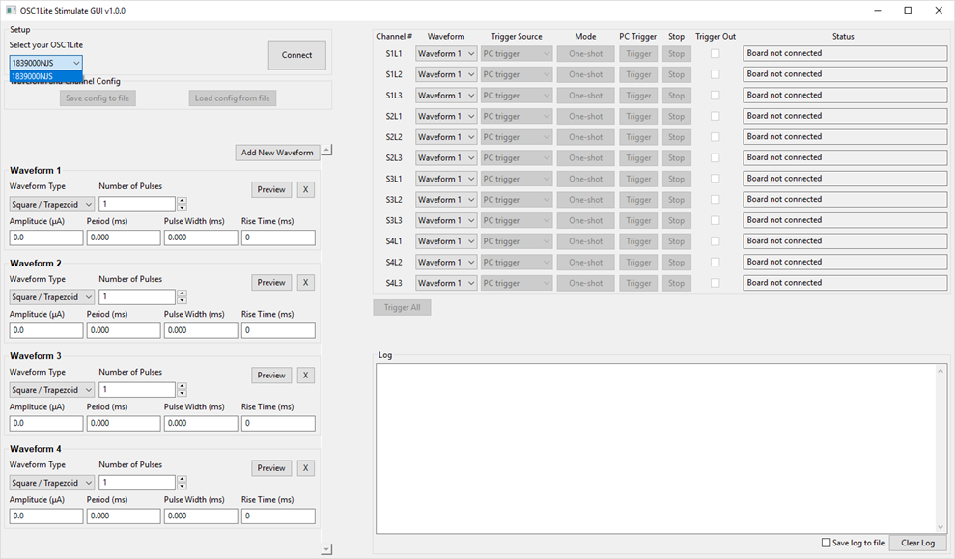

**Figure 5** OSC1Lite GUI

The first step to complete upon opening the GUI is selecting which Opal Kelly to connect with. A “drop-box” of all connected Opal Kelly devices (connected via USB cable) (**Figure 5**) allows you to select your Opal Kelly based on its serial number. The last 3 alphanumeric characters of the Opal Kelly module can be seen next to the barcode of the Opal Kelly module (**Figure 4**).

## Waveform Setup

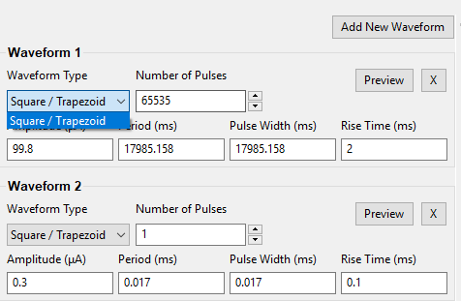 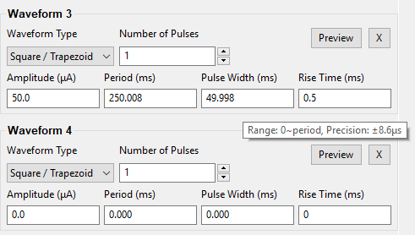

**Figure 6** Waveform parameters

At the moment, only square/trapezoidal waveforms are available. You can paramterize these in as many waveforms as you’d like by adding more waveforms via the ‘Add New Waveform’ button. Hover over parameters to see their valid ranges. Warning: when a new parameter is entered, all channels affected are paused, awaiting re-trigger. Custom waveform and multi-waveform previews are coming soon.

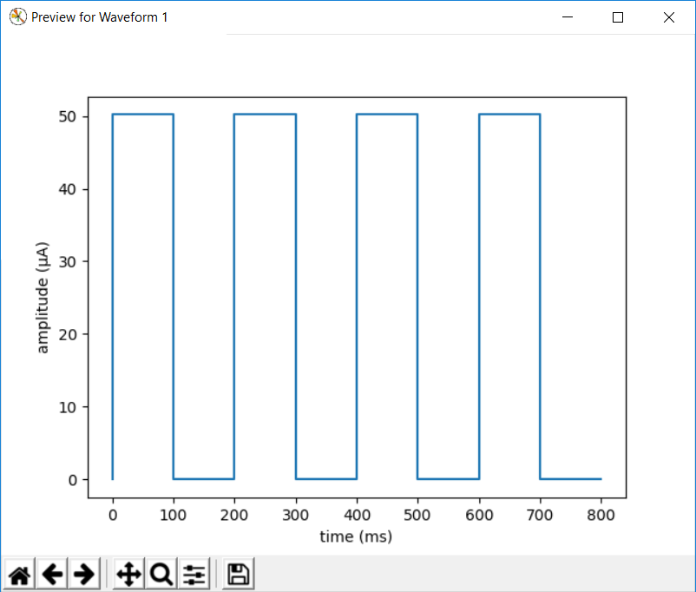

**Figure 7** Waveform preview

**Table 2** Valid waveform parameter ranges

|  |  |  |
| --- | --- | --- |
| **Parameter** | **Valid Range** | **Precision (nominal)** |
| Waveform Type | Square / Trapezoid |  |
| Number of Pulses | Integers from 1 to 65535 |  |
| Amplitude | 0 to 100 (μA) | ±0.31μA |
| Pulse Width | 0 to 17,900.000 ms | ±8.6μs |
| Pulse Period | 0 to 17,900.000 ms | ±8.6μs |
| Rise Time | 0, 0.1ms, 0.5ms, 1ms, 2ms |  |

## Calibration

Each board is calibrated at the Yoon Lab. If you believe your board is outputting incorrect current beyond the specifications please send an email to [ContactMINT@umich.edu](mailto:ContactMINT@umich.edu) for re-calibration.

## Channel Control

### Channel to LED mapping

Each channel has a corresponding ‘Channel #’ (see **Figure 5**) to indicate which LED on the probe the channel is stimulating. For example, S1L1 corresponds to shank 1, μLED 1, as seen below in **Figure 9**.

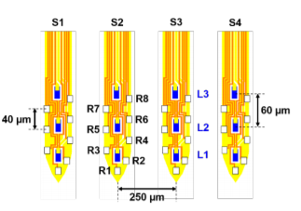

**S1L1**

**Figure 9** Optoelectrode LED map

### Waveform selection

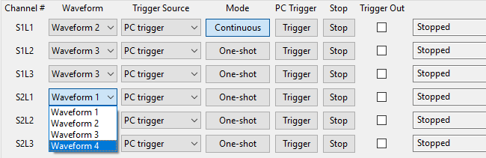

**Figure 10** Waveform selection

Assign any waveform to any channel. Warning: selecting a new waveform will pause that channel.

### Trigger source

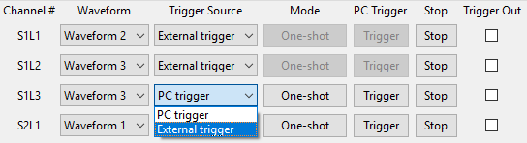

**Figure 11** Trigger source

Select how channels should begin stimulation:

1. PC trigger: the channel shall start stimulating upon clicking the “Trigger [All]” button
2. External trigger: the channel shall start stimulating whenever a TLL (3.3-5V OK) is seen on the corresponding **Trigger In** pin (see **Figure 12** below).

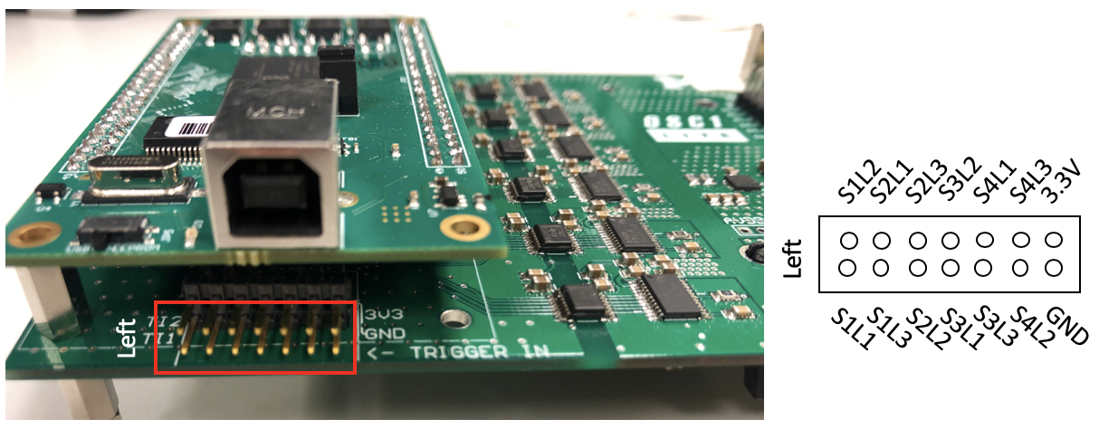

**Figure 12** Trigger in pins

To stop stimulation on a channel, click the corresponding “Stop” button. Otherwise to stop all channels, disconnect from the board.

### Channel mode

1. One-shot: stimulation stops after the # of specified pulses are sent on the channel
2. Continuous: stimulation continues indefinitely (nominally)

### Trigger out

When this box is selected, a TTL pulse (with the same width as the waveform width) is sent out on the corresponding pin (see **Figure 13** below).

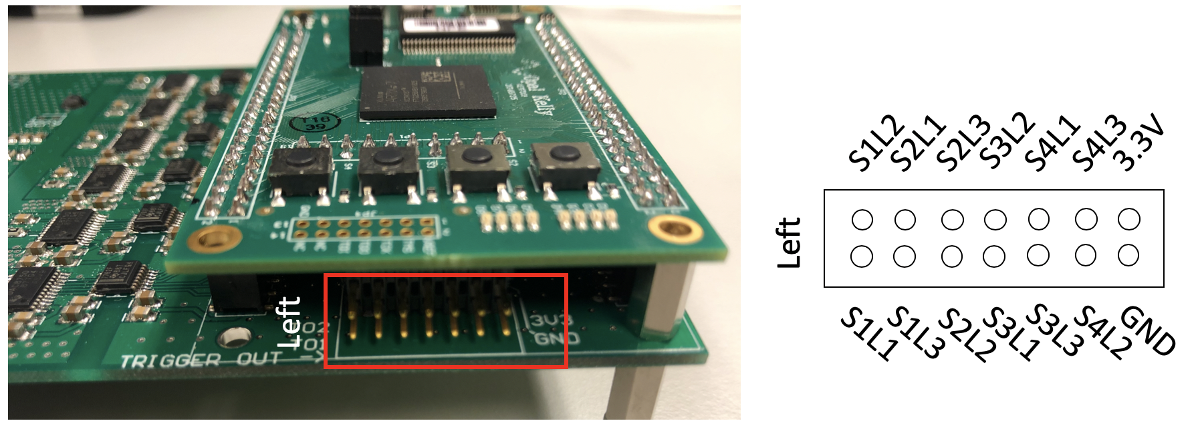

**Figure 13** Trigger out pins

### Channel status

Each channel may indicate a unique status, as outlined below in **Table 3**.

**Table 3**. Channel status descriptions

|  |  |
| --- | --- |
| **Status** | **Description** |
| Board not connected | The board is not connected to the GUI.  Click the ‘Connect’ button on GUI. |
| Stopped | The channel is outputting 0 current. |
| Normal | The channel is sending the waveform. |
| Alarm | The alarm will provide explicit error information. Please refer to **Table 4**. |

**Table 4.** Alarm descriptions

|  |  |
| --- | --- |
| **Alarm** | **Description** |
| DAC open circuit or compliance voltage violation | There is an open circuit or a compliance voltage violation in IOUT loading. The user can check the circuit and wire connection. |
| DAC die temperature over 142 degC | The DAC die temperature is over 142°C. The user can restart the whole system. |
| DAC code is slewing | DAC code is slewing as determined by SRCLK and SRSTEP. The user can restart the whole system. |
| DAC watchdog timer timeout | There is watchdog timer timeout. The user can restart the whole system. |
| DAC SPI CRC error | There is CRC error on SPI frame. The user can restart the whole system. |

# Troubleshooting

If you have any questions, please make sure you’ve read this manual as well as the μLED datasheet. You can then post a question on our [google group](https://groups.google.com/forum/#!topic/michigan-optoelectrodes/gAg2t58qPjc), only after searching for a similar question. If no one responds within a few days, then feel free to send an email to [ContactMINT@umich.edu](mailto:ContactMINT@umich.edu).

## Dead channels and alarms

If any of the alarms on a channel are persistent, try checking the health of the LED (see below). One way to test if channels are operating correctly is by setting non-zero parameters (amplitude, pulses, pulse width, period) and triggering all channels with no probe attached –All channels should indicate “Open Circuit” –Any channel that indicates “Normal” is not operating correctly. If this happens send an email to [ContactMINT@umich.edu](mailto:ContactMINT@umich.edu) for resolution.

## Dead μLEDs

See our [google group](https://groups.google.com/forum/#!topic/michigan-optoelectrodes/gAg2t58qPjc). OSC1Lite has been tested on μLED optoelectrodes which have survived overnight stimulation of 100, 200 and 300 μA of current (12 hours continuously). However, μLED failure does occur; MINT is currently working on performing longevity testing and characterization to better understand and improve μLED optoelectrode durability and performance.

## Noisy μLEDs (stimulation artifact)

See our [google group](https://groups.google.com/forum/#!topic/michigan-optoelectrodes/gAg2t58qPjc). Recently we have introduced a grounded metal layer for shielding the recording traces from the stimulation traces on the probe, which significantly reduces the stimulation artifact. However, there are some μLEDs that seem to couple to every channel –we are working to find the root cause and fix it.

## Calibration

Each board is calibrated at the Yoon Lab. If you believe your board is outputting incorrect current beyond the specifications please send an email to [ContactMINT@umich.edu](mailto:ContactMINT@umich.edu) for re-calibration.

1. <https://mint.engin.umich.edu/technology-platforms/#optoelectrodes>
2. <https://github.com/YoonGroupUmich/osc1lite>
3. After 6 months
4. Output current when channel is set to 0uA (for example, during the off-phase of a waveform pulse). If you see LEDs lighting up when current is set to 0, either the LED is dead, or the channel has malfunctioned. Send an email to [ContactMINT@umich.edu](mailto:ContactMINT@umich.edu) for resolution.
5. Custom waveform and multi-waveform visualization coming soon
6. It is recommended to “wiggle” the connector horizontally back and forth to connect/disconnect the Omnetics cables.
7. <https://github.com/YoonGroupUmich/osc1lite>
8. For example, OSC GUI might attempt to connect to an Intan Opal Kelly board if using 4.5.5